# **Crucial Git commands for Banking Bot development**

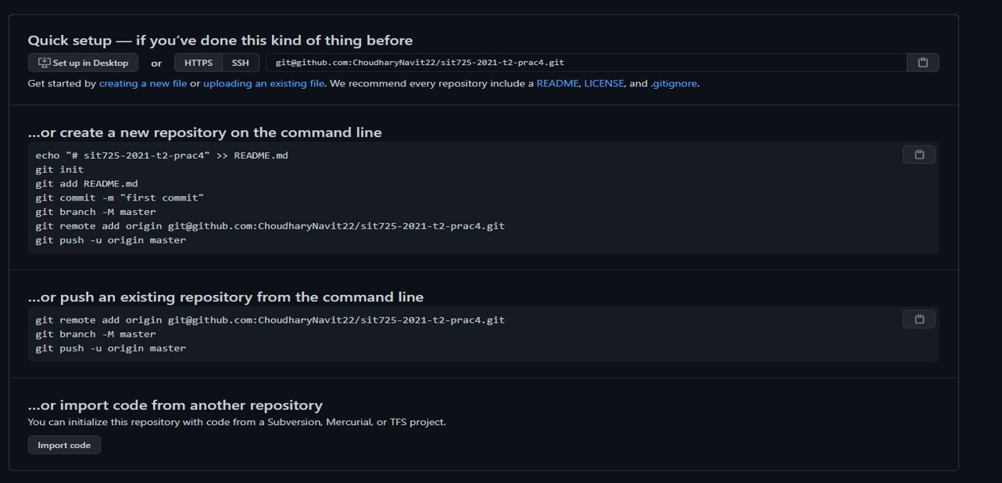

## **Clone repository**

If you want to clone a repository which has been created in GitHub, you can do that using the following command.

Git clone <Remote repository>

The remote repository is https://github.com/Banking-Bot-Project/web_code.git

## **Checkout and push**

git checkout -b <NAME> - this way you can select your own branch to work on.

git branch – this gives you the current branch you are working on.

git status - this way you can find what files have you changed

git commit -a -this way you can commit work you are done so far

git push – finally you can push all your work to the remote branch

## **Create a pull request**

Once you have done a git push you need to go to the GitHub site to create a pull request. It is under your branch then only someone can merge it into the main repository.

## **Find current branch**

This shows the current branch you are working on

Git branch

## **Find what have you changed**

Following commands gives you the files you have worked on

Git status

Git diff

## **Find you have the current copy of the branch**

Git pull -here if you have the current version of the repo then it says Already up to date.